P2 Report
Reasoning:
The task requires choosing the most cost-efficient sorting algorithm based on different costs. Selection sort, Insertion sort and Bubble sort have different characteristics in terms of comparisons and swaps, so we need to estimate the cost of them before actual sorting. Accord to the material, we need only focus on the reads/writes performed on the input array.

The estimation uses a simplified cost model. It assumes worst-case behaviour.

For Selection sort,
We need to compare [(n-1) + (n-2) + (n-3) + … + 1] = (n-1) *n/2 times and we need to swap at most (n-1) times.
Therefore,
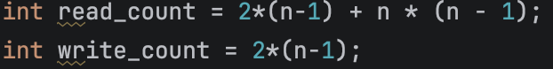

For Insertion sort,
We need to compare [(n-1) + (n-2)+ … +1] = (n-1)*n/2 times and we need to swap the same times as that of comparison.
Therefore,
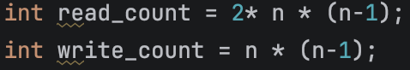
For Bubble sort,
We need to compare (n-1)*n times and We need to swap [(n-1) + (n-2)+ … +1] = (n-1)*n/2 times.
Therefore,
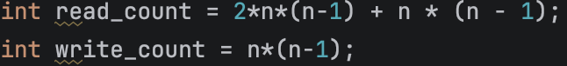

After estimation of each sorting method, we could know which one is the most efficient way. And then choose the most efficient way to deal with this task.

Evidence of Testing:
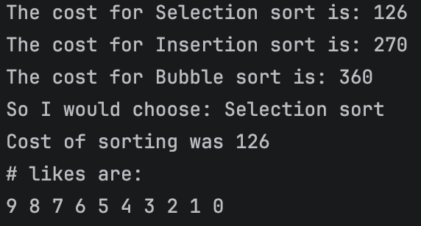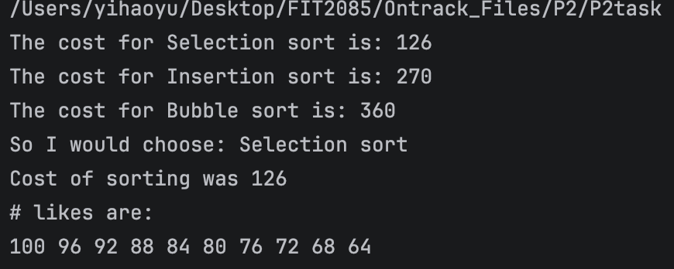
Word Count: 185.

